Quickbooks To Salesforce Migration process

Migration of Customers in Quickbooks to Accounts in Salesforce
Step1 : In the “Quickstart “ window all the default mappings are listed in the left menu.
Step2 : Select the CustomerToAccount state and check the Status Check Box to make it part of integration, as shown in the Screen shot below.

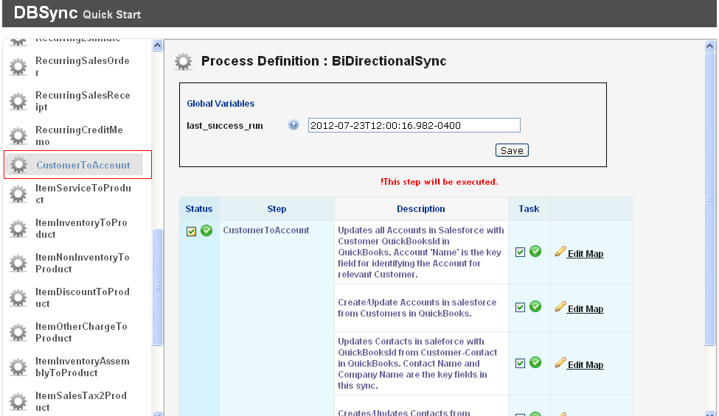

Note : Similarly you can select or deselect other mappings as required.
To Migrate the data from the required date.
Step1 : Go to Quick Start window.
Step2: From the left Menu Select the CustomerToAccount state.
Step3 : In the “Last Success Run” Edit the date from when you want to Migrate the data and Click on Save.
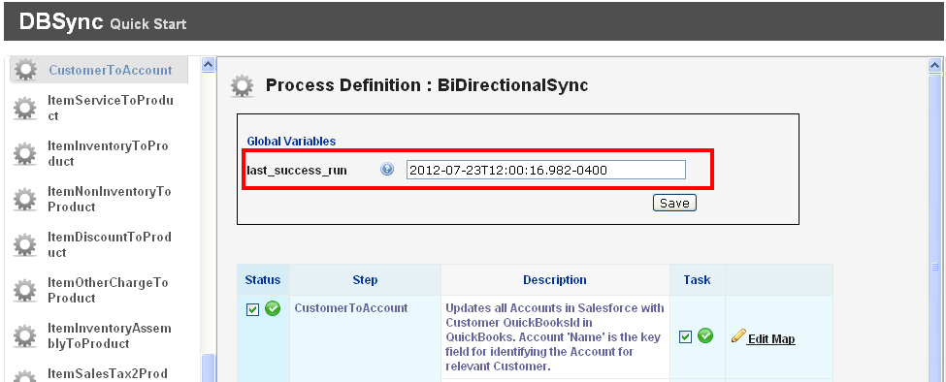
Note : Similarly you can Edit the Last_Success_Run for the other mappings as required.
Once you are done with the mappings go to your QuickBooks Web Connector by Start Programs QuickBooks Web Connector and Run the Sync.
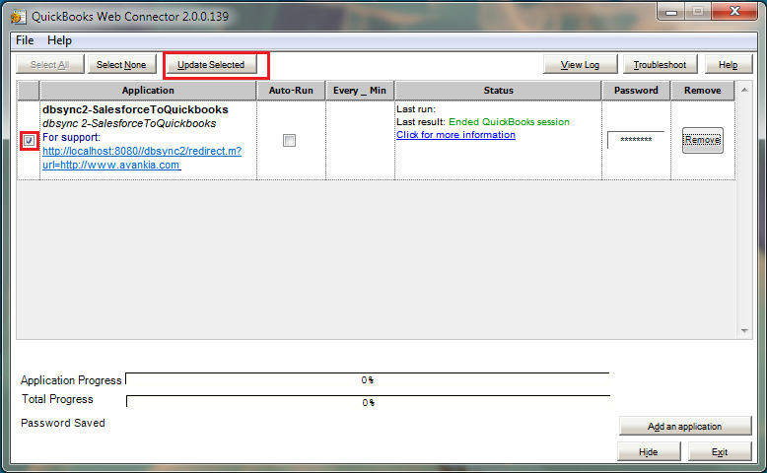

Migration of Items in Quickbooks to Products in Salesforce
Step1: Go to “Quickstart” window all the default mappings are listed in the left menu.
Step2: Select the ItemServiceToProducts state and check the Status Check Box to make it part of integration. As shown in the screen shot below.
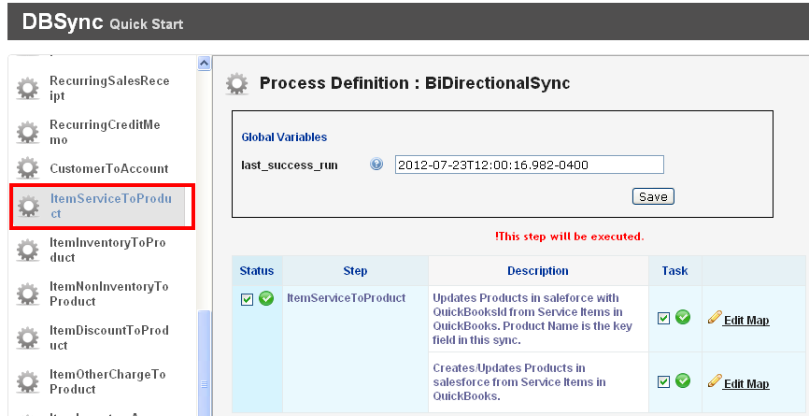
Note : Similarly you can select or deselect other mappings like ItemInventoryToProduct, ItemNonInventoryToProduct as required.
To Migrate the data from the required date.

Step1 : Go to Quick Start window.
Step2: From the left Menu Select the ItemServiceToProducts.
Step3 : In the “Last Success Run” Edit the date from when you want to Migrate the data and Click on Save.
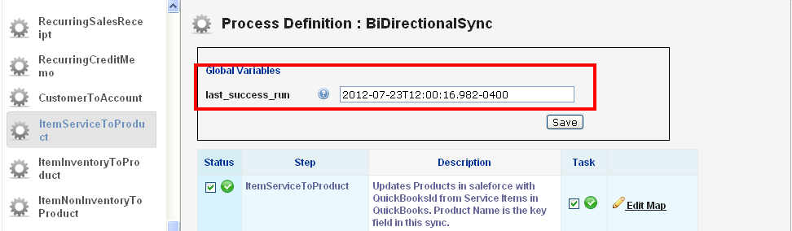
Note : Similarly you can Edit the Last_Success_Run for the other mappings as required.
Once you are done with the mappings go to your QuickBooks Web Connector by Start Programs QuickBooks Web Connector and Run the Sync.

Migration of Invoices in Quickbooks to Opportunity in Salesforce
Step1: Go to “Quickstart” window all the default mappings are listed in the left menu.
Step2: Select the InvoiceToOpportunity state and check the Status Check Box to make it part of integration. As shown in the screen shot below
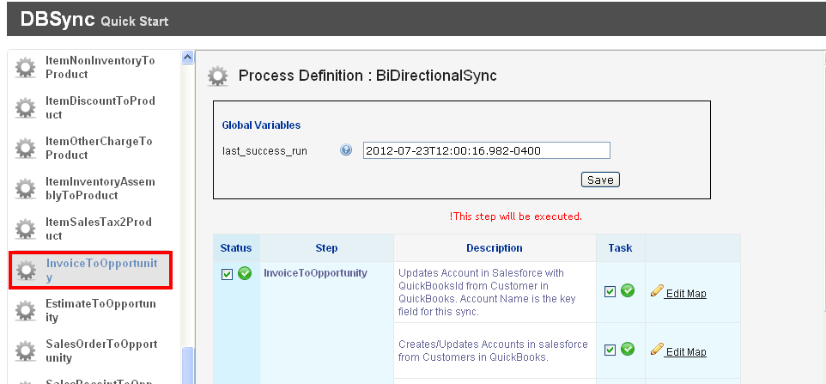
Note : Similarly you can select or de-select other mappings like EstimateToOpportunity, SalesOrderToOpportunity as required.

To Migrate the data from the required date.
Step1 : Go to Quick Start window.
Step2: From the left Menu Select the InvoiceToOpportunity.
Step3 : In the “Last Success Run” Edit the date from when you want to Migrate the data and Click on Save.
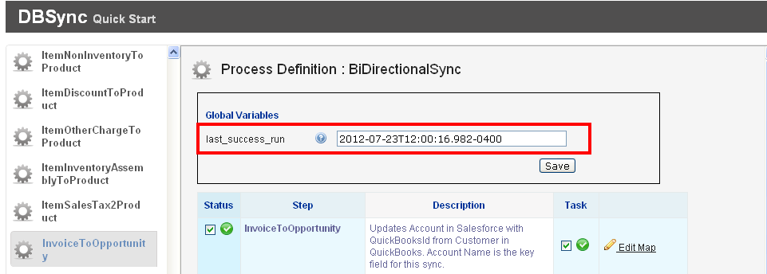
Note : Similarly you can Edit the Last_Success_Run for the other mappings as required.
Once you are done with the mappings go to your QuickBooks Web Connector by Start Programs QuickBooks Web Connector and Run the Sync.

